## **PRACTICAL 9:**

## **AIM:** Input-Output

**Program 1:**

Write program to copy content of one file to another file.

Source Code:

Refer main program.

1. **Program 2:**
2. Write a program to merge the content of files.

Source Code:

Refer main program.

1. **Program 3:**

Write a program to write student details in a file.

Source Code:

package lab9;

import java.util.*;

import java.util.*;

import java.io.*;

//import lab9.Student;

public class Stu implements Serializable

{

public int en_no;

public String name;

public Stu()

{

}

public Stu(int en_no,String name)

{

this.en_no=en_no;

this.name=name;

}

public void setEn_no(int n )

{

en_no=n;

}

public void setName(String na )

{

name=na;

}

public int getEn_no()

{

return en_no;

}

public String getName()

{

return name;

}

public String toString()

{

return getEn_no()+" "+getName();

}

}



## **Main Program:**

package main;

import lab9.*;

import java.io.*;

import java.util.Scanner;

public class Main9

{

public static void filecopy()

{

FileInputStream ob=null;

FileOutputStream obx=null;

try

{

ob= new FileInputStream("abc.txt");

obx=new FileOutputStream("xyz.txt");

byte[] buffer=new byte[1024];

int i;

while((i=ob.read(buffer))!=-1)

{

obx.write(buffer,0,i);

//System.out.println((char)i);

//i=ob.read();

}

}

catch(Exception e)

{

System.out.println("\nIOException");

}

finally{

try{

ob.close();

obx.close();

}

catch(Exception e)

{

System.out.println("\nIOException");

}

}

}

public static void mergefiles()

{

FileInputStream ob1=null;

FileInputStream ob2=null;

FileOutputStream obj=null;

try{

ob1= new FileInputStream("abc.txt");

ob2= new FileInputStream("xyz.txt");

obj=new FileOutputStream("final.txt");

byte[] buffer=new byte[1024];

int i;

while((i=ob1.read(buffer))!=-1)

{

obj.write(buffer,0,i);

}

while((i=ob2.read(buffer))!=-1)

{

obj.write(buffer,0,i);

}

}

catch(Exception e)

{

System.out.println("\nIOException");

}

finally{

try{

ob1.close();

ob2.close();

obj.close();

}

catch(Exception e)

{

System.out.println("\nIOException");

}

}

}

public static void Studentmain()

{

Stu S1 = new Stu();

FileOutputStream fout=null;

ObjectOutputStream out=null;

S1.setEn_no(123);

S1.setName("neha");

System.out.println(S1.en_no+" "+S1.name);

try

{

fout=new FileOutputStream("student.txt");

out=new ObjectOutputStream(fout);

out.writeObject(S1.toString());

System.out.print("objects successfully written");

}

catch(Exception e)

{

System.out.print(e);

}

finally

{

try

{

fout.close();

}

catch(Exception e)

{

System.out.println("exception occured");

}

}

}

public static void main(String a[])

{

int ch;

Scanner o=new Scanner(System.in);

System.out.println("1.Copy Content from one file to other\n2.Merge two files\n3. Write student details in file\n");

System.out.println("Enter your choice: ");

ch = o.nextInt();

switch(ch)

{

case 1:{

filecopy();

break;

}

case 2:{

mergefiles();

break;

}

case 3:{

Studentmain();

break;

}

default:{

System.out.println("\nEnter valid choice");

break;

}

}

}

}

Output:

For program 1:

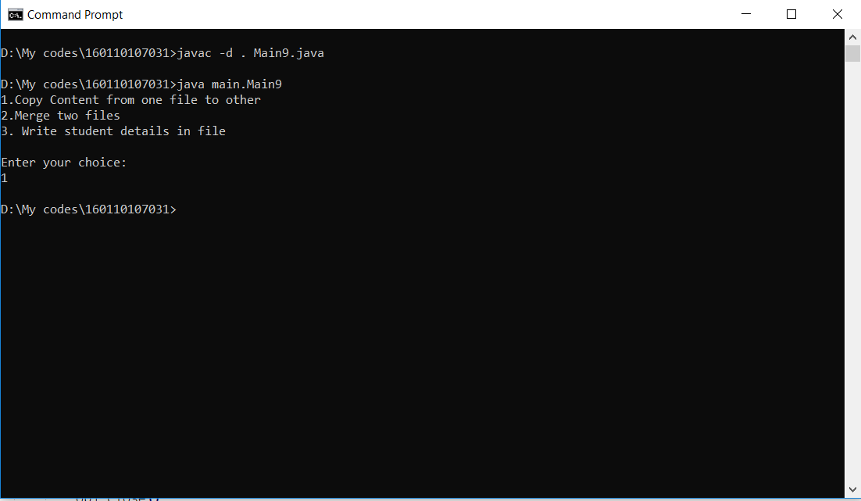

Abc.txt:

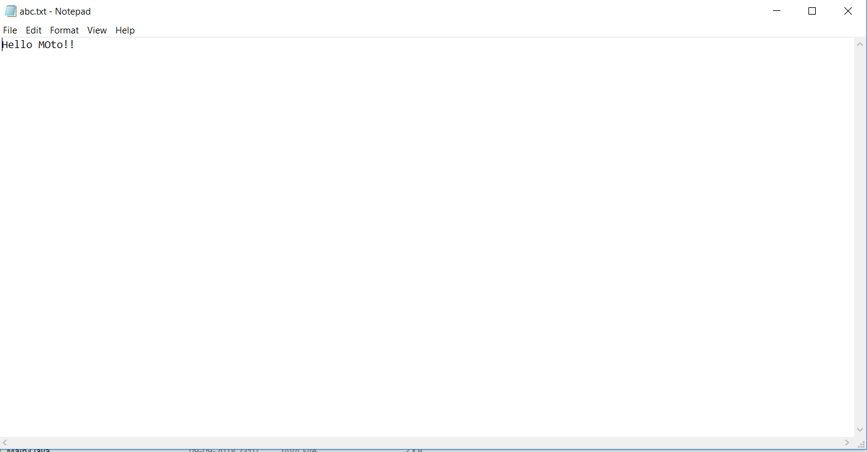

Xyz.txt:

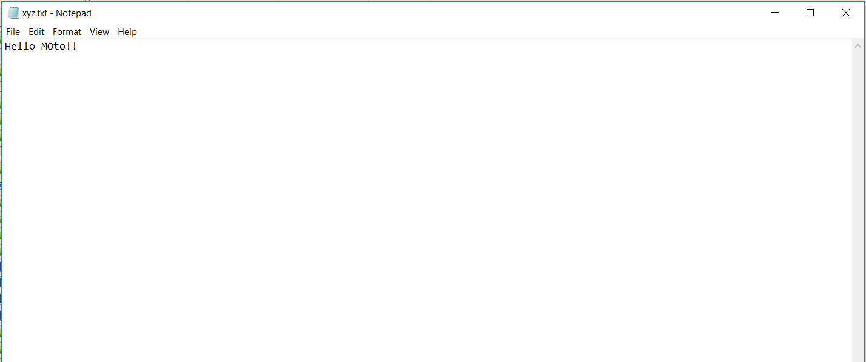

For program 2:

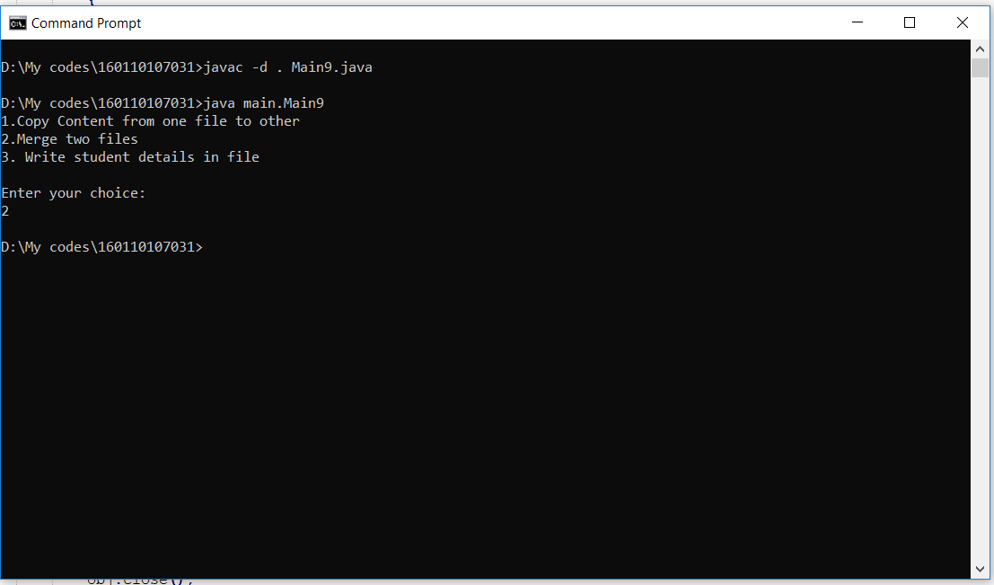

Abc.txt and xyz.txt are same as above

Final.txt:

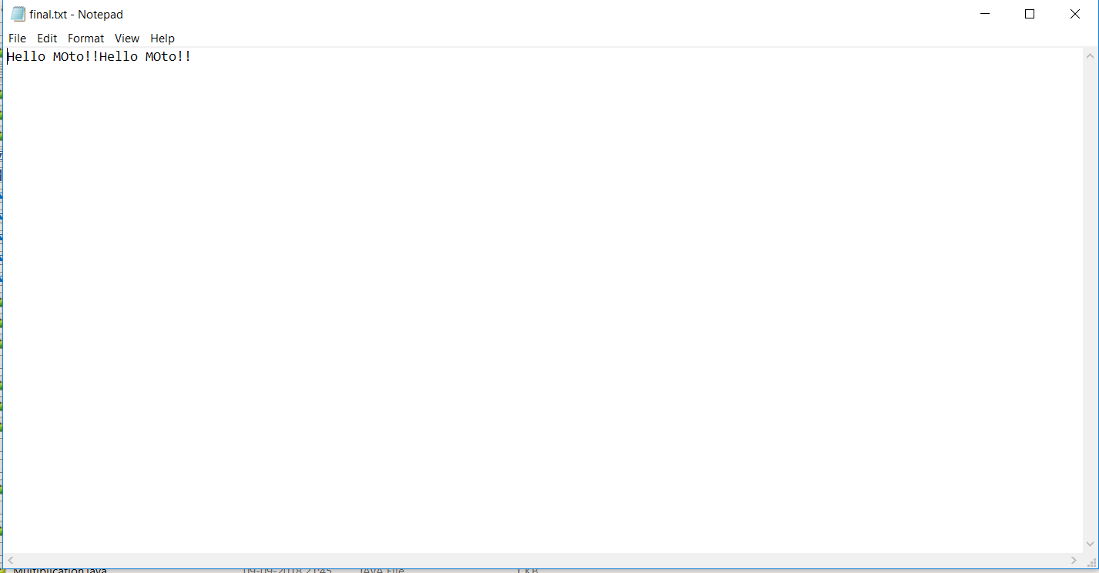

For Program 3:

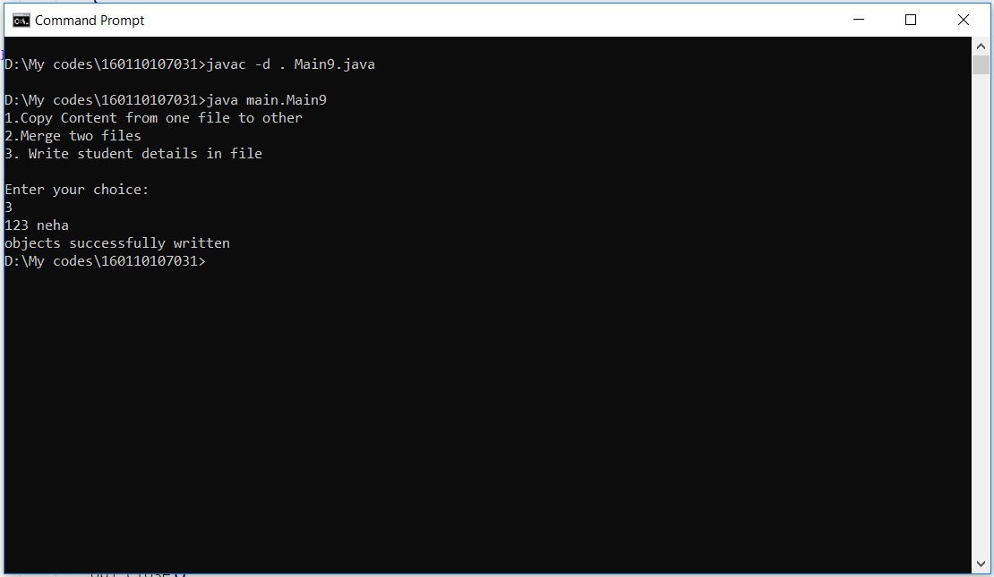

Student.txt(the file containing the student’s details):

